Name________________________________ Number _____ Date ____________
10 people bought pumpkin pies at the WES bake sale. Miss Ann asked each person how many pumpkin pies they bought and wrote it down on post- it notes. Here is the data she collected:


1 2 2 2 2 5 5 6 6 9

Display the data on a bar graph. Remember to include title, labels, and numbers.

TITLE: ______________________________
NUMBER OF _____________________________

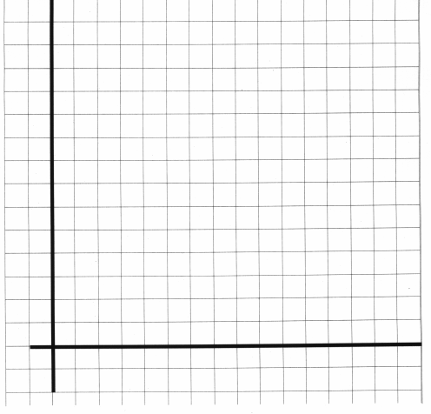

NUMBER OF _________________________

